13.82: a) 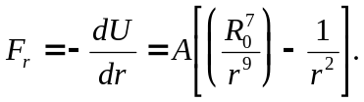
b) Setting the above expression for 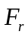 equal to zero, the term in square brackets vanishes, so that 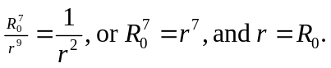

c) 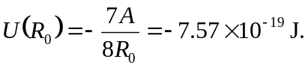

d) The above expression for can be expressed as

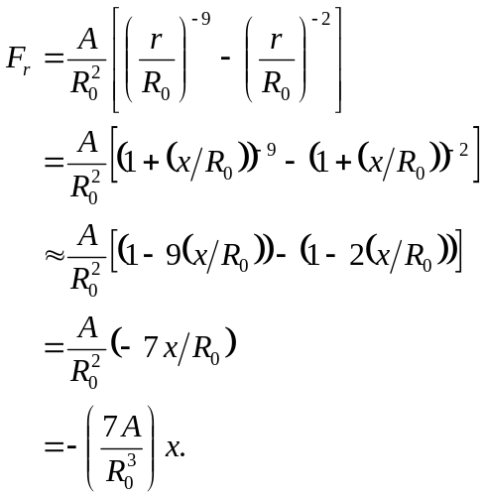

e) 